
Lessons from the Land of

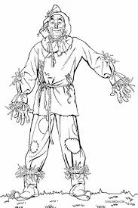

The Scarecrow – Young lady, use your ____________.
Proverbs 4:13- Take fast hold of instruction; let her not go: keep her; for she is thy life.

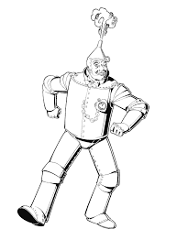

The Tin Man –Young lady, guard your ______________.
Proverbs 31:30 Favour is deceitful, and beauty is vain: but a woman that feareth the Lord, she shall be praised.

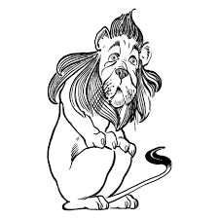
Lion- Young lady, have ___________________.

Isaiah 41:10- Fear thou not; for I am with thee: be not dismayed; for I am thy God: I will strengthen thee; yea, I will help thee; yea, I will uphold thee with the right hand of my righteousness

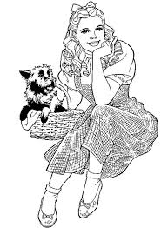
Dorothy- Young lady, have__________________.
Hebrews 11:6- But without faith it is impossible to please him: for he that cometh to God must believe that he is, and that he is a rewarder of them that diligently seek him.
www.Jenniferchesneywhite.com

